

**School of Computer Science And Engineering (SCOPE) B.Tech – Computer Science And Engineering**

**Submitted By 19BCE1777 – PUJARA RAHI**

**Submitted To**

**Dr.S.Geetha**

**DATE: 27/12/2021**

Content-Based Medical Image Retrieval

Abstract :

* Medical imaging is essential nowadays throughout medical education, research, and care.
* Accordingly, international efforts have been made to set large-scale image repositories for these purposes.
* Yet, to date, browsing of large-scale medical image repositories has been troublesome, timeconsuming, and generally limited by text search engines.
* A paradigm shift, by means of a queryby-example search engine, would alleviate these constraints and beneficially impact several practical demands throughout the medical field.
* The current project aims to address this gap in medical imaging consumption by developing a content-based image retrieval (CBIR) system, which combines two image processing architectures based on deep learning.
* Furthermore, a first-of-its-kind intelligent visual browser was designed that interactively displays a set of imaging examinations with similar visual content on a similarity map, making it possible to search for and efficiently navigate through a large-scale medical imaging repository, even if it has been set with incomplete and curated metadata.
* Users may, likewise, provide text keywords, in which case the system performs a content- and metadata-based search.
* The system was fashioned with an anonymizer service and designed to be fully interoperable according to international standards, to stimulate its integration within electronic healthcare systems and its adoption for medical education, research and care.
* Professionals of the healthcare sector, by means of a self-administered questionnaire, underscored that this CBIR system and intelligent interactive visual browser would be highly useful for these purposes.
* Further studies are warranted to complete a comprehensive assessment of the performance of the system through case description and protocolized evaluations by medical imaging specialists.

Keywords :

* clinical
* content-based image retrieval
* education
* imaging
* interactive visual browser
* query-by-example

Introduction :

* Nowadays, imaging plays a central role in medicine.
* Large amounts of imaging data are constantly generated in daily clinical practice, leading to continuously expanding archives, and ever progressive efforts are being made across the world to build large-scale medical imaging repositories .
* This trend is in line with the increasing medical image consumption needs, which have been studied and categorized into four groups: patient care-related, research-related, education-related, and other .
* In the era of big data, however, navigating through large-scale medical imaging archives is becoming, correspondingly, increasingly troublesome.
* Browsing any available, large-scale medical imaging repository through a conventional text-based search engine is time-consuming, severely hampered if the repository lacks curated or expert-annotated metadata, the search results display options are limited.
* Conversely, the need for collecting curated or expert-annotated metadata may, in turn, be preventing the building of large, multi-center, international medical imaging repositories that meet the medical imaging needs of today.
* In this scenario, there is an enormous need for efficiently archiving, organizing, managing, and mining massive medical image datasets on the basis of their visual content (e.g., shape, morphology, structure), and it may be expected that this demand will only become more substantial in the foreseeable future.
* Looking towards their implementation in the daily clinical workflow, however, there remain technical challenges.
* Large-scale repositories, reciprocally, are needed for CBIR systems to deliver appealing search results.
* For that purpose, in turn, local teams with experience in the use of healthcare integration standards are required.
* For multi-center collaborative efforts, there is also needed a data extractor inside each institution to anonymize, and transfer and convert data to a standardized semantic term.
* The aim of the present project was to develop a CBIR system using learned latent image representation indexation, with a visual content, similarity-based, intelligent and interactive visual browser for efficient navigation.
* The system was developed using international standards to be fully interoperable to ease integration into routine clinical workflow and, thus, support current medical image demands throughout education, research and clinical care.
* Novel deep learning architectures have also empowered internal image representation learning, specifically, latent representations, which can be used to implement ground-breaking image content search engines .
* Formally, a CBIR system is a quadruple {D, Q, F, R (qi , dj )}, where:
* (i) D is a set composed of representations for the images in a given collection,
* (ii) Q is a set of representations for user information needs, operationally known as queries,
* (iii) F is a representational framework that allows images, queries, and their relationships to be jointly modeled, and, finally,
* (iv) R(qi , dj ) is a ranking function which associates a real number with a query qi in Q and an image dj in D. The ranking defines an ordering among the images in a given collection regarding the query q.

Problem statement :

* This keynote presentation aims at giving a historical perspective of how medical image retrieval has evolved from a few prototypes using first only text, then global visual features to the current multimodal systems that can index many types of images in large quantities and use deep learning as a basis for the tools .
* It also aims at looking at what the place of image retrieval is in medicine, where it is currently still only sparsely used in clinical practice.
* It seems that it is mainly a tool for teaching and research.
* Certified medical tools for decision support rather make use of specific approaches for detection and classification.

Motivation:

* Medical imaging is one of the largest data producers in the world and over the last 30 years this production increased exponentially via a larger number of images and a higher resolution, plus totally new types of images.
* Most images are used only in the context of a single patient and a single time point, besides a few images that are used for publications or in teaching.
* Data are usually scattered across many institutions and cannot be combined even for the treatment of a single patient.
* Much knowledge is stored in these medical archives of images and other clinical information and content-based medical image retrieval has from the start aimed at making such knowledge accessible using visual information in combination with text or structured data.
* With the digitization of radiology that started in the mid 1990s the foundation for broader use was laid out.

Approach:

* The presentation follows a systematic review of the domain that includes many examples of systems and approaches that changed over time when better performing tools became available.
* Medical mage retrieval has evolved strongly, and many tools linked to mage retrieval are now employed as clinical decision support but mainly for detection and classification.
* Retrieval remains useful but is often integrated with tools and thus has become almost invisible.
* A second aspect of the presentation includes a presentations of existing data sets and other resources that were difficult to obtain even ten years ago, but that have been shared via repositories such as TCGA , TCIA , or via scientific challenges such ImageCLEF or listed in the Grand Challenges web page .

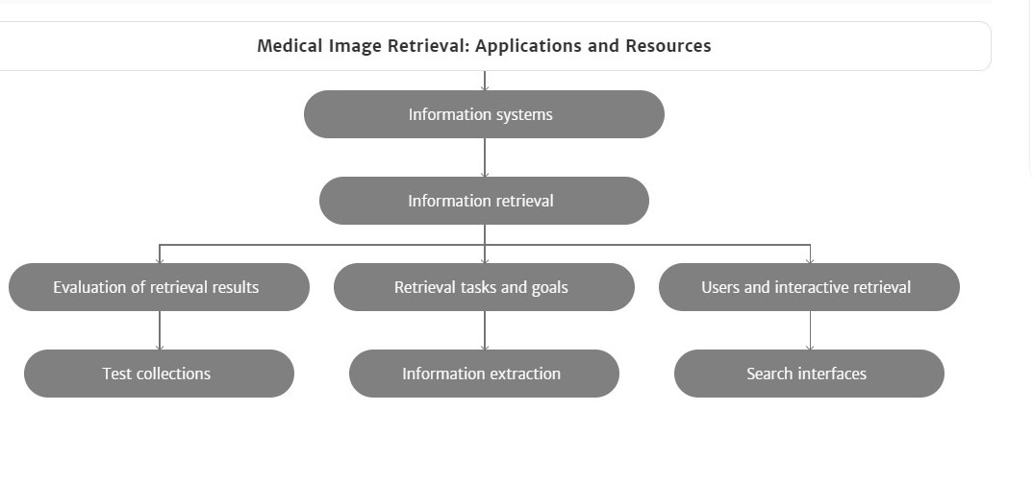

Literature Survey :

* Image preprocessing is the first step of image retrieval to ensure accuracy of subsequent steps.
* The images acquired through different modalities cause many artifacts such as low resolution, noise and extra cranial tissue etc.
* which reduces the accuracy of acquired result.
* In order to overcome the above problem preprocessing of an image is required.
* An analysis on filtering techniques such as Gabor & QMF filters for noise is performed by .
* These primitive methods along with reducing the noise blur the important and detailed structure necessary for subsequent steps.
* In order to increase the processing speed and to reduce the error probability of mammogram images Morphological top hat filtering algorithm is utilized in .
* But these types of filtering are applicable for mammogram images only. To eliminate the noise in images, Gaussian filter is suggested in .

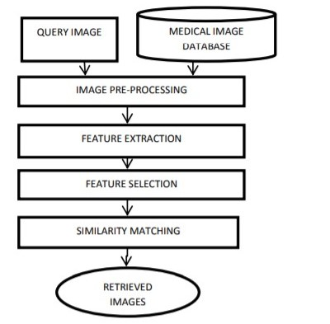

Algorithm :

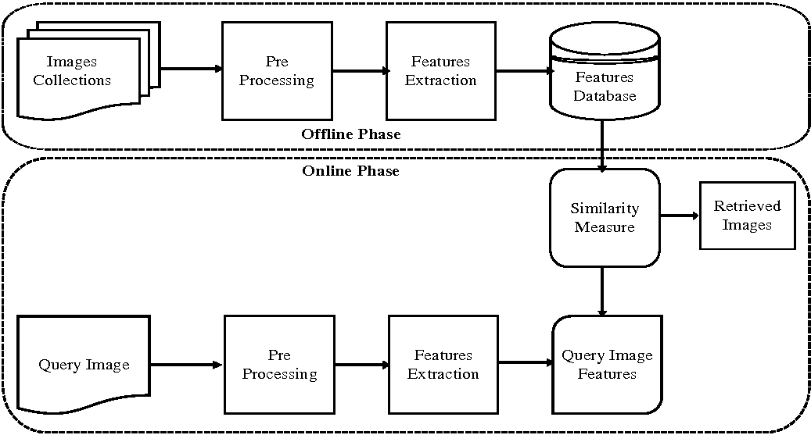

Dataset Software - Hardware Needed; ML/DL Model for matlab :

* Operating Systems
* Windows 11
* Windows 10 (version 1909 or higher)
* Windows 7 Service Pack 1
* Windows Server 2019
* Windows Server 2016
* Note:
* On Windows 11, MATLAB R2021b update 1 is required.
* Support for Windows 7 will be discontinued in an upcoming release.
* RAM
* Minimum: 4 GB
* Recommended: 8 GB
* For Polyspace, 4 GB per core is recommended
* Processors
* Minimum: Any Intel or AMD x86-64 processor
* Recommended: Any Intel or AMD x86-64 processor with four logical cores and AVX2 instruction set support
* Disk
* Minimum: 3.4 GB of disk space for MATLAB only, 5-8 GB for a typical installation
* Recommended: An SSD is recommended

A full installation of all MathWorks products may take up to 30 GB of disk space

CODE :

clc;clear;close all

%% Getting Image

i=imread('/MATLAB Drive/cs-tracking-lung-cancers-path-alt-722x406.jpg');

figure(1)

imshow(i);title('Original Photo')

% if image is rgb

try

i=rgb2gray(i);

end

%% Crop The Breast

z=im2bw(i,0.1);

figure(2)

imshow(z);title('Original B&W')

info=regionprops(z);

a=cat(1,info.Area);

[m,l]=max(a);

X=info(l).Centroid;

bw2=bwselect(z,X(1),X(2),8);

i=immultiply(i,bw2);

figure(3)

imshow(i);

title('Getting the Breast and Muscle')

%% Deleting Black Ground

% We will delete the black corners

% So that we can select the muscle

% using bwselect

% convert to B&W first time

[x,y]=size(z);

tst1=zeros(x,y);

% detect empty rows

r1=[];

m=1;

for j=1:x

if z(j,:)==tst1(j,:)

r1(m)=j;

m=m+1;

end

end

% detect empty columns

r2=[];

m=1;

for j=1:y

if z(:,j)==tst1(:,j)

r2(m)=j;

m=m+1;

end

end

% Deleting

i(:,r2)=[];

i(r1,:)=[];

figure(4)

imshow(i);title('after deleting background');

%% Deleting the Muscle

if i(1,1)~=0

c=3;

r=3;

else

r=3;

c=size(i,2)-3;

end

z2=im2bw(i,0.5);

bw3=bwselect(z2,c,r,8);

bw3=~bw3;

ratio=min(sum(bw3)/sum(z2));

if ratio>=1

i=immultiply(i,bw3);

else

z2=im2bw(i,0.75);

bw3=bwselect(z2,c,r,8);

ratio2=min(sum(bw3)/sum(z2));

if round(ratio2)==0

lvl=graythresh(i);

z2=im2bw(i,1.75*lvl);

bw3=bwselect(z2,c,r,8);

bw3=~bw3;

i=immultiply(i,bw3);

else

bw3=~bw3;

i=immultiply(i,bw3);

end

end

figure(5)

imshow(i)

title('Getting only the Breast')

%% Weiner Filter

% We will create average mask [3 3]

% with SNR = 0.2

mask=fspecial('average',[3 3]);

SNR=0.2;

i=deconvwnr(i,mask,SNR);

figure(6)

imshow(i)

title('Weiner Filter')

%% Clahe Filter

i=adapthisteq(i);

figure(7)

imshow(i)

title('Clahe Filter')

**OUTPUT :**

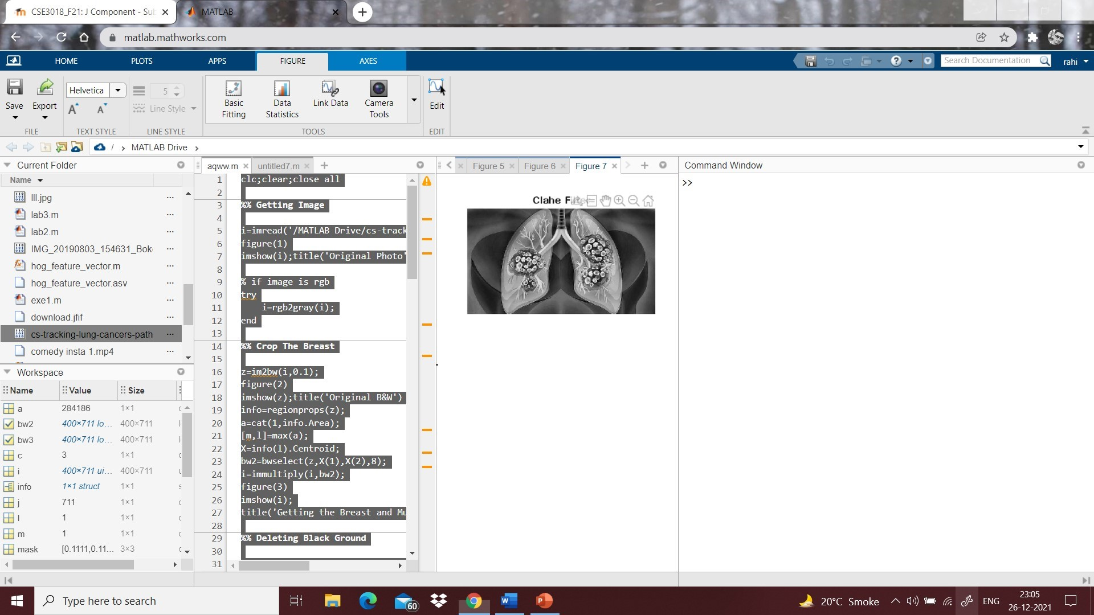

**MRI:**

% MATLAB code for

% Separate the brain part from MRI image.

% read the mri image.

k=imread("/MATLAB Drive/download.jfif");

% display the image.

imtool(k,[]);

% convert it into binary image.

k1=im2bw(k,graythresh(k));

% display the binary image.

imtool(k1);

% Make the brain largest connected component.

% We need to apply opening operation.

% define the structuring element.

SE=strel('disk',7,4);

% apply the opening operation.

k2=imopen(k1,SE);

% display the image now.

imtool(k2);

% apply connected component analysis.

b=bwlabel(k2);

% display the colored map image.

imtool(b,[]);

% brain is component labeled as 9.

% set all other component as 0 except brain.

b(b~=9)=0;

% display the brain part.

imtool(b);

% inside the brain part, black portion is there.

% close the black pixels inside brain part.

k3=imclose(b,strel('disk',18));

% display the brain part.

imtool(k3);

% extract the brain from original image.

k4=k3.*double(k);

% display the real brain from original image.

imtool(k4,[]);

**OUTPUT :**

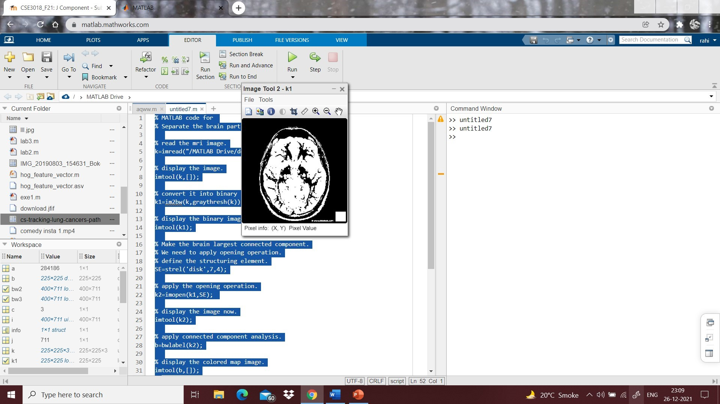

Conclusions :

* We developed a deep learning-based CBIR system and a first-of-its-kind intelligent visual browser that interactively displays on a similarity map a set of imaging examinations with similar visual content, making it possible to search for and efficiently navigate through a large-scale medical imaging repository, even if it has been set with incomplete and curated metadata.
* The system was fashioned with an anonymizer service and designed to be fully interoperable according to international standards in order to stimulate its integration within healthcare systems and its adoption for medical education, research, and care.
* Professionals of the healthcare sector, by means of a self-administered questionnaire, underscored that this CBIR system and intelligent interactive visual browser would be highly useful for these purposes.
* Further studies are warranted to complete a comprehensive assessment of the performance of the system through case description and protocolized evaluations by medical imaging specialists.

References:

* Smith-Bindman, R.; Miglioretti, D.L.; Johnson, E.; Lee, C.; Feigelson, H.S.; Flynn, M.; Greenlee, R.T.; Kruger, R.L.; Hornbrook, M.C.; Roblin, D.; et al. Use of diagnostic imaging studies and associated radiation exposure for patients enrolled in large integrated health care systems 1996–2010. JAMA 2012, 307, 2400–2409.
* Smith-Bindman, R.; Kwan, M.L.; Marlow, E.C.; Theis, M.K.; Bolch, W.; Cheng, S.Y.; Bowles, E.J.A.; Duncan, J.R.; Greenlee, R.T.; Kushi, L.H.; et al. Trends in use of medical imaging in us health care systems and in Ontario, Canada 2000–2016. JAMA 2019, 322, 843–856.
* Kalpathy-Cramer, J.; García, A.; De Herrera, S.; Demner-Fushman, D.; Antani, S.; Bedrick, S.; Müller, H. Evaluating performance of biomedical image retrieval systems-an overview of the medical image retrieval task at Image CLEF. Comput. Med. Imaging Graph. 2014, 39, 55–61
* Li, Z.; Zhang, X.; Müller, H.; Zhang, S. Large-scale retrieval for medical image analytics: A comprehensive review. Med. Image Anal. 2018, 43, 66–84.
* Müller, H.; Rosset, A.; Garcia, A.; Vallée, J.P.; Geissbuhler, A. Benefits of content-based visual data access in radiology. Radiographics 2005, 25, 849–858.